**B.TECH. (2020-24)**

**Artificial Intelligence**

**Open Ended**

**LAB File**

on

**Fundamentals of Machine Learning**

**[CSE313]**

Submitted To

**Dr Monika Arora**

Submitted By

|  |  |  |
| --- | --- | --- |
| **Hitesh** | **A023119820027** | **5AI 1** |
| **Gauri Tyagi** | **A023119820028** | **5AI 1** |
| **Kushagra Dubey** | **A023119820029** | **5AI 1** |
| **BHOOMIKA SHARMA** | **A023119820030** | **5AI 1** |
| **SUNIDHI SINGH** | **A023119820032** | **5AI 1** |

DEPARTMENT OF COMPUTER SCIENCE AND ENGINEERING

AMITY SCHOOL OF ENGINEERING AND TECHNOLOGY

AMITY UNIVERSITY UTTAR PRADESH

NOIDA (U.P)

**OPEN ENDED EXPERIMENT**

**Aim**

To implement k means clustering algorithm over a dataset

**Software Used**

Google Colab

**Theory**

K-Means Clustering is an [Unsupervised Learning algorithm](https://www.javatpoint.com/unsupervised-machine-learning), which groups the unlabeled dataset into different clusters. Here K defines the number of pre-defined clusters that need to be created in the process, as if K=2, there will be two clusters, and for K=3, there will be three clusters, and so on. It is a centroid-based algorithm, where each cluster is associated with a centroid. The main aim of this algorithm is to minimize the sum of distances between the data point and their corresponding clusters. The performance of the K-means clustering algorithm depends upon highly efficient clusters that it forms. But choosing the optimal number of clusters is a big task.

### **Elbow Method**

The Elbow method is one of the most popular ways to find the optimal number of clusters. This method uses the concept of WCSS value. **WCSS** stands for **Within Cluster Sum of Squares**, which defines the total variations within a cluster.

To find the optimal value of clusters, the elbow method follows the below steps:

* It executes the K-means clustering on a given dataset for different K values (ranges from 1-10).
* For each value of K, calculates the WCSS value.
* Plots a curve between calculated WCSS values and the number of clusters K.
* The sharp point of bend or a point of the plot looks like an arm, then that point is considered as the best value of K.

**Program Code and Output**

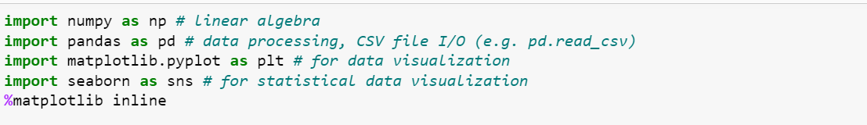

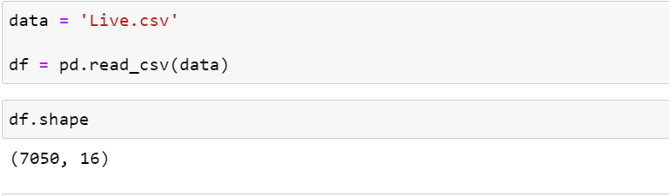

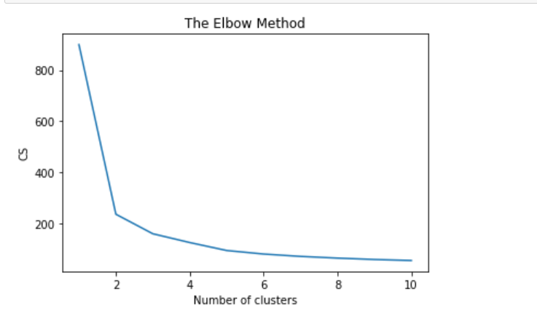

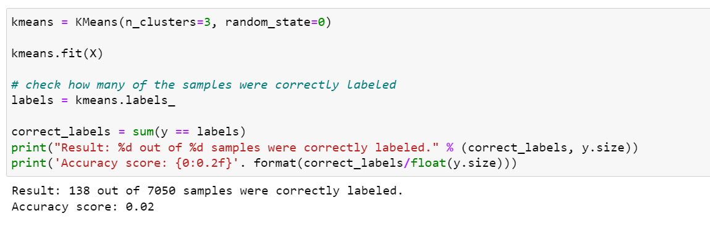

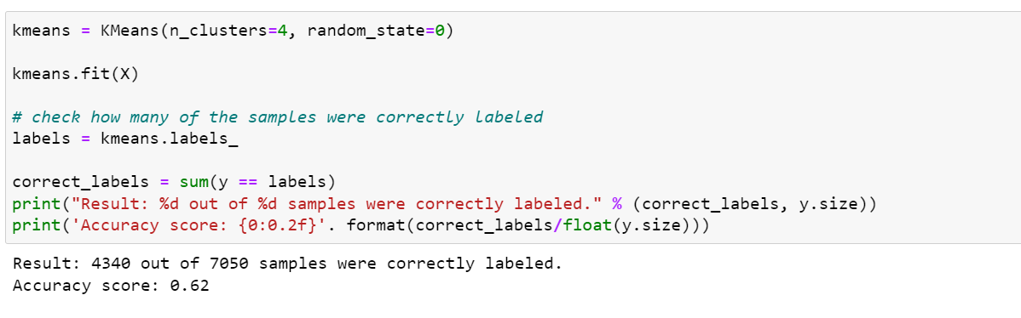

**Discussion and Conclusion**

The lesser the model inertia, the better the model fit. So, we use the elbow method to find optimal number of clusters. There is a kink at k=2.Hence k=2 can be considered a good number of the cluster to cluster this data. So, we have changed the value of k and found relatively higher classification accuracy of 62% with k=4. Hence, we can conclude that k=4 being the optimal number of clusters.

